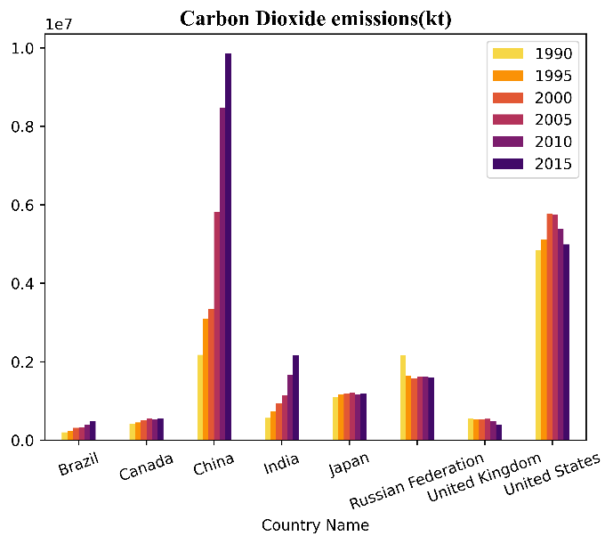

The bar graphs above shows the Carbon Dioxide emissions(kt) and Nitrous Oxide emissions(thousand metric tons of CO2 equivalent) of 8 countries throughout the 25 year period from 1990. The Y-axis scales are deliberately different here because what I hope to do is more of a comparative analysis of the impacts each of these indicators have on climate change.

China leads both the Carbon dioxide and Nitrous oxide emissions by a huge margin, that too with a rigid upward trend. China is followed by the United States in both indicators with it’s peak values throughout the years still under China’s values a decade ago. Canada and United Kingdom however stays very low in both the graphs.

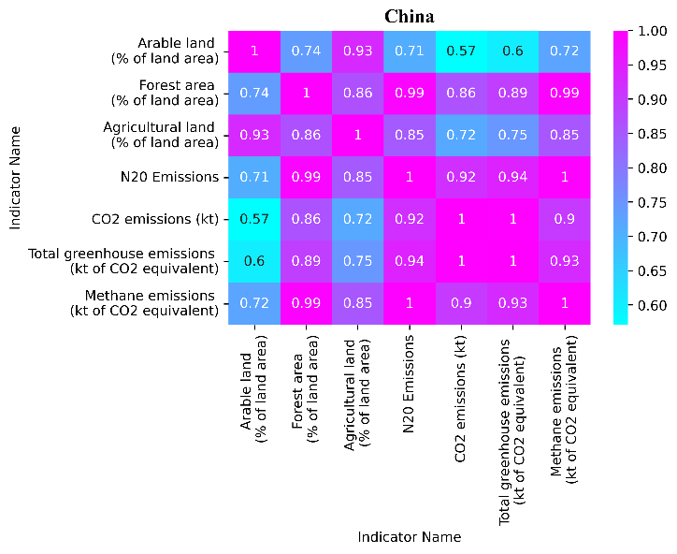

If we take a look at the correlation heatmap of China above we can see that the total greenhouse emissions of the country has a perfect and near perfect correlations with the nitrous oxide and carbon dioxide emissions respectievely.

**Climate change data analysis with World Bank Data**

**In this project I attempt to analyse some of the climate change indicators including emissions of two of the most daunting greenhouse gases- Carbon Dioxide and Nitrous Oxide and how it connects to other indicators like the percentage of Arable land of total area. Correlation heatmaps are used to explore the relationships between these and some other indicators of certain countries.**

We can observe a huge increase in the Nitrous Oxide emissions comparing the bars of Brazil and India in the above graph. Not only are they more than twice of their respective Carbon Dioxide emissions, they are increments significant on a global scale.

Nitrous oxide emissions for Canada, Japan, Russian Federation and the United Kingdom are slightly more than what they were in Carbon dioxide emissions. All these inferences were with respect to China and United States, both of which had similar bar lengths.

What I was working towards was the question : Which of these countries contribute more greenhouse gas emissions and how exactly do they impact global warming and climate change ?

Evidently China and the United States are the highest and second highest contributors of greenhouse gas emissions since they are both higher by a huge margin in both cases. What I want to explore here is the impact each of these gases have on climate change.

Carbon Dioxide is merely the most predominant greenhouse gas, not the most impactable. It is found that each N2O molecule has two hundred and ninety eight times the global warming potential of a CO2 molecule. Therefore the impact the much higher increase in Nitrous Oxide emissions of Brazil and India has is tremendous.

Bacteria in the soil release nitrous oxide. The use of nitrogen-rich fertilisers, tilling and soil cultivation, and livestock waste management are some of the contemporary agricultural methods that considerably increase nitrous oxide emissions. So let’s take a look at the percentage of agricultural land (of total land area) of these countries.

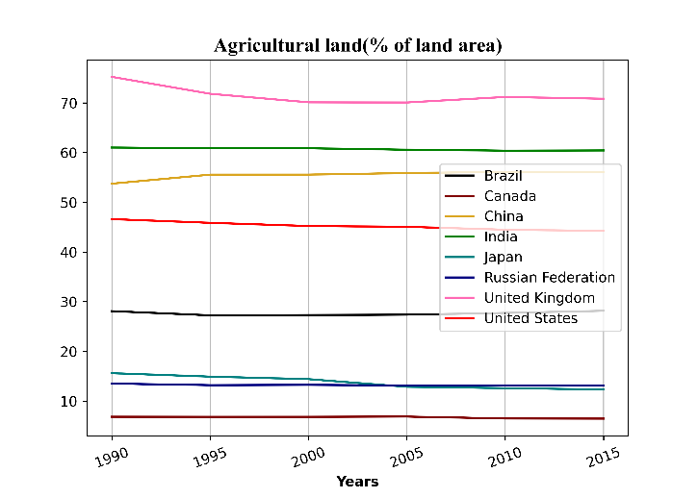

We can see that United Kingdom and India has the most percentage of agricultural land. United Kingdom has about 70% of its land as agricultural land whereas India has around 60% in the righter end of the graph. Note that for Brazil only around 30% is agricultural land. When we take into account the fact that around 5.6% of the world’s total landmass belongs to Brazil, 2.6% of India and just 0.2% for United Kingdom, we can see that the total agricultural land area of Brazil is immensely larger than that of the rest and India’s 2.6% constitute way more land than the 70% of United Kingdom. We can interpret this as one of the reason for the immense Nitrous Oxide emissions from Brazil and India.

Let’s take a look at Brazil’s heatmap.

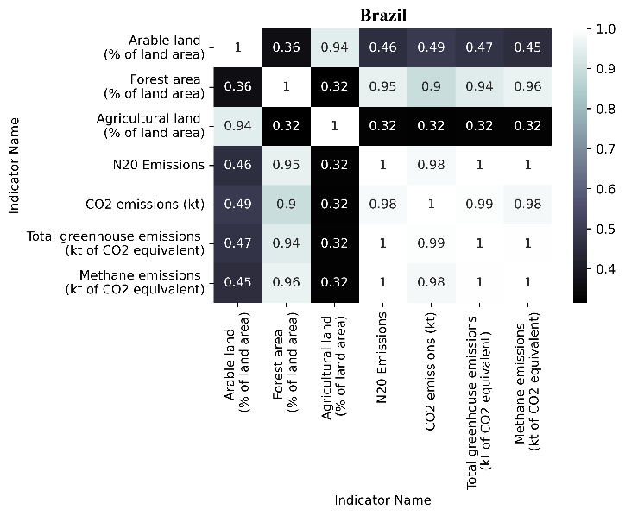

The percentage of forest area of total land area has a near perfect correlation with Nitrous oxide emission as expected. It also has a similar correlation with the total greenhouse gas emissions. Forest soil is a rich source of bacteria and this is why we can see such strong positive values between N2O emissions and forest area land.

Let’s now take a look at the correlations heatmaps of some other countries to look over another Indicator.

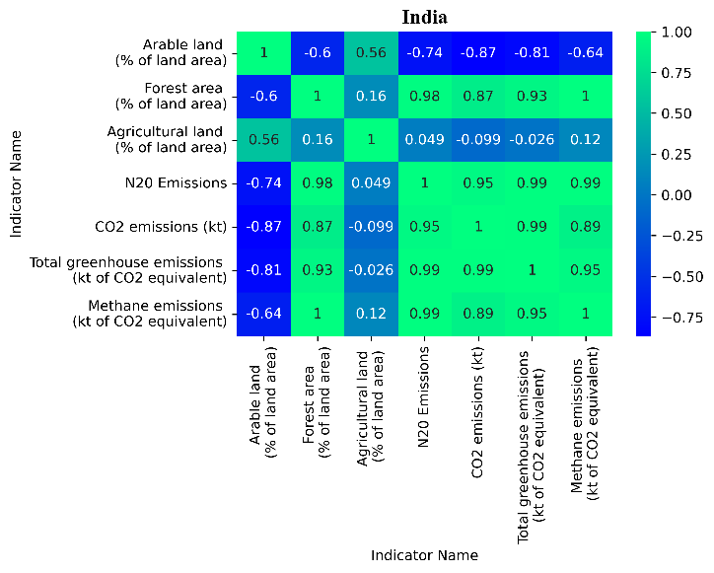

We can see that the percentage of forest area of total area has a perfectly positive correlation with methane emission. One of the main causes of methane emission is decomposition of plant matter and this is clear from the correlation values for each of these countries.

If we take look at China’s heatmap on the previous page we can again see that all of these correlation values are similar for these countries. Carbon dioxide being the most common source of greenhouse emissions does not make it the strongest contributor of global warming. We need to work towards fighting climate change and we need to start now. Information like this can be useful in our fight against climate change.